Revolutionizing Online Shopping: A Comprehensive Review of an Automated Size Recommendation and Immersive 3D Visualization System for Virtual Try-On Enhancement

HMG Divyanjalee  
*Department of Computer Science   
General Sir John Kotelawala Deefence University*Rathmalana, Sri Lanka  
38-bse-0003@kdu.ac.lk

WMKS Ilmini  
*Department of Computer Science   
General Sir John Kotelawala Deefence University*Rathmalana, Sri Lanka  
kalamiilmini@kdu.ac.lkGAI Uwanthika  
*Department of Computer Science   
General Sir John Kotelawala Deefence University*Rathmalana, Sri Lanka  
uwanthika.gai@kdu.ac.lk

*Abstract*— In the last decade, the landscape of shopping has been significantly reshaped by the rapid growth of e-commerce and mobile commerce. The fashion industry's shift to e-commerce has resulted in customers being unable to try on clothes before buying, leading to high return rates and dissatisfaction [1]. However, despite the substantial progress in online sales, the persistent challenge of clothing fit has impeded the seamless purchasing of clothes online. This paper critically evaluates advanced virtual try-on techniques and systems, focusing on automatic size recommendation systems and 3D visualization techniques. It aims to identify key findings, identify knowledge gaps, and assess the advantages and limitations of these methods. The study contributes to the ongoing discourse on improving the global online clothing purchasing experience, making it more convenient, enjoyable, and efficient for consumers. Throughout the review process, an accurate and systematic search approach was employed, ensuring a thorough exploration of prominent academic databases. Additionally, the study considered the necessary of resolving research gaps and addressing potential limitations, emphasizing the importance of transparency in acknowledging any biases or constraints encountered during the review process. In conclusion, this paper contributes to the ongoing discussion on improving the efficiency and overall experience of online clothing purchasing for consumers worldwide. It underscores the potential transformative impact of innovative solutions in reshaping the fashion industry and enhancing customer satisfaction within the realm of online shopping.

Keywords—*size recommendation, virtual try-on, 3D model, apparel industry, online shopping, recognition, e commerce, user measurement*

# Introduction

Over the past five to ten years, e-commerce and mobile commerce have become integral parts of our lives. According to the China Internet Network Information Centre (CNNICC) [2] clothing, shoes, and hats rank among the top five product categories purchased online. However, despite the impressive online sales figures, it is still very difficult to sell clothes online because of the complicated problem of clothing fit. People frequently find that the clothes they ordered online don't suit when it comes to, prompting exchanges or refunds. According to the researches, the most common complaints about online clothes purchases are about fit and size, with "fit" serving as the primary reason for returns. Additionally, the uncertainty surrounding clothing suited not only contributes to a high return rate but also impacts on customers' overall satisfaction with e-stores/brands, resulting in sales losses.

In recent years, the fashion industry has undergone a profound transformation, primarily driven by the surge in online shopping and e-commerce. However, online retailers grapple with a significant challenge – customers cannot physically try on clothes before purchasing, leading to elevated return rates, wastage, and customer dissatisfaction. This paper offers an in-depth review of state-of-the-art virtual try-on techniques discussed in previous research and systems. According to figure 01, clothing represents the highest category of returned e-commerce purchases[3]. Whilst various applications have attempted to address this issue, several limitations persist. This paper critically examines the existing approaches, highlighting their limitations and shortcomings. In the subsequent literature review section, we explore innovative technologies and strategies to address these issues effectively.

Figure 01: percentage of returned e-commerce purchases [3]

The research outlined in this study seeks to revolutionize online dress shopping by tackling a significant challenge that many customers encounter when selecting the right dress size. Traditional online shopping lacks the physical try-on experience, resulting in uncertainties regarding size suitability and a high return rate, ranging from 20% to 40%. Previous systems have struggled to effectively address this problem.

# literature review

This literature review aims to provide an overview of the key developments, trends, and challenges in the realm of online applications in the virtual try-on concept. The existing published literature on this topic is relatively limited but has shown promising developments. Several studies have investigated the use of machine learning algorithms, such as neural networks and decision trees, to develop personalized size recommendation systems. These systems utilize user data, such as body measurements and preferences, to provide accurate fitting suggestions for virtual try-ons. The available literature provides valuable insights into the methodologies and performance evaluation metrics used in developing these systems.

Although the number of publications in this field is currently limited, they demonstrate a growing interest in improving the virtual try-on experience through customized 3D clothing size recommendation systems. As this area gains popularity, it is expected that more research will be conducted to further refine and improve the accuracy and efficiency of these systems. According to previous reviews these are the key points that this research categorized into the 3 sub sections: Recommendation Systems, 3D Visualization and virtual try on.

## Recommendation Systems

According to previous research, many data collection approaches are accessible for the development of 3D clothing size recommendation systems. These methods include a combination of techniques such as body scanning combined with user input, the use of neural networks, and image processing, which involves capturing two images of the user, etc. [4] [5] [6].

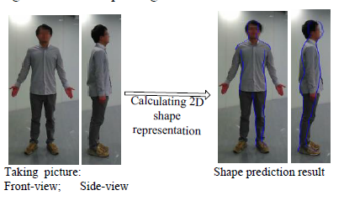

Figure 02: 2D shape representation [4]

Existing systems focus on user satisfaction in customized 3D clothing size recommendation systems. Many previous researchers have identified that machine learning techniques have shown promising results in predicting suitable clothing sizes for individual users. These algorithms consider factors like body measurements, style preferences, and clothing attributes. This highlights the potential of machine learning to improve online shopping experiences by tailoring recommendations to users’ unique needs, thereby increasing satisfaction. The research underscores the importance of addressing challenges in the widespread adoption of these systems.

Considering about the size recommendation systems, there are few systems that exist to recommend the dress size. Lots of systems are for dress style recommendations and the virtual try one in 3D models. We found some 3D models which are very accurate to the human body, and some are not. Existing virtual try-on methods have focused on realistic visualization of clothed human images but have not adequately addressed the issue of garment fit [7] [6].

There is a system for Clothing Recommendation System based on Visual Information Analytics [8] which consists of 2 main stages: Personal information prediction, Clothing attributes recognition and recommendation system. The result of this system shows that the system is reliable and robust to the consumers, especially when the personal information and the color features are considered.

ClothFit [9] a system, is made up of an attribute classifier, a U-Net-based AGVTON, and a cloth auto-encoder. We used the dataset produced by the 3D physics simulation program Blender to train the suggested networks. The experimental findings demonstrated that the suggested method generated the virtual try-on photographs along with the real human and fabric properties and synthesized the virtual try-on images better than state-of-the-art models. Our suggested system has the potential to be employed in a variety of fields, including e-commerce and fashion design. The virtual try-on system can help buyers try on clothes online before buying them, which can save time and money. This approach overcomes some of issues in the online shopping.

Figure 03: Architecture of ClothFit [9]

Ying Yuan et. [10] proposed a clothing size recommendation system designed for online shopping malls, with a focus on reducing excessive inventories and return rates. The system employs data-based size extraction and recommendation functions, as well as a user-friendly interface. This study collects and sorts of reference data for recommendation when clients provide height, weight, and other body size factors. Women, men, and children are the study's scope sizes. Men's sizes range from S-5XL, women's sizes range from 2XS-3XL, and children's sizes range from 1, 6, 9 months, and 2-15 years of age. When uploading a product, the real size of the garment is coded in terms of size coding in comparison to the client numerical value. It utilizes Chinese standard body size data (GB/T) to recommend sizes based on a customer's height and weight. The research achieved an approximate 88% matching rate for women and 80% for men, with better accuracy for upper-body clothing. However, limitations were observed due to outdated GB/T data and the need for more segmented body size information. The study emphasizes the importance of continuously updating and expanding the dataset for more accurate recommendations.

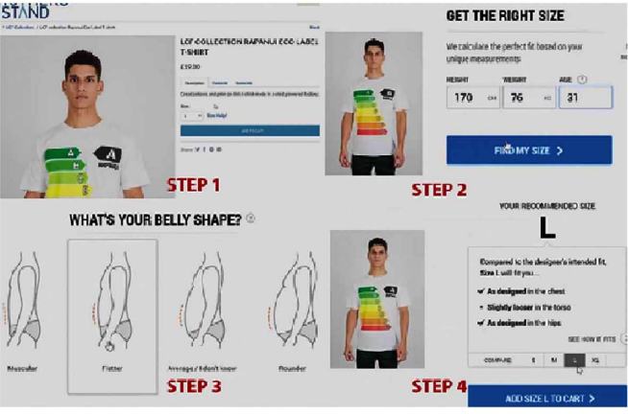

Figure 04: Size Recommendation system interface [10]

Taobao [11], a prominent online shopping platform, offers size input and recommendation features. However, it lacks automatic size extraction, relying on customers to input their sizes manually, assuming they know their measurements accurately. Taobao also provides a user-friendly interface for easy comparison between the sizes entered by the shop owner and the customer. Surprisingly, this function is underutilized, as many customers prefer to estimate sizes by visually assessing product images and reading postscripts from customers with similar body types. Factors contributing to the infrequent use of the size input function include sellers not inputting clothing sizes separately, making them reliant on reference images for size charts. Additionally, customers may struggle with accurately measuring their own body sizes, leading to potential errors in input.

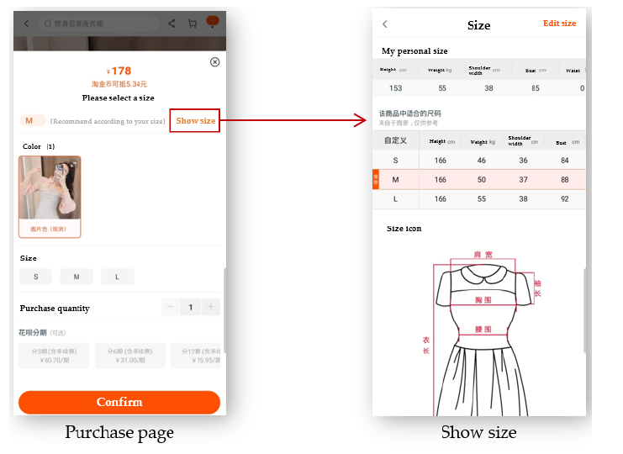

Figure : Taobao’s size recommendation system interface [11]

## Immensive 3D Visualization

Immersive 3D visualization plays a key role in enhancing the virtual try-on experience in online shopping. This section focuses on the importance of realistic and interactive visualizations that enable customers to virtually try on clothes and assess the fit, appearance, and overall look. Researchers have explored different approaches to creating immersive 3D environments and evaluate their impact on customer satisfaction and purchasing behavior.

Rough body posture prediction from this type of sensor data is addressed by existing commercial and research systems [12], but there are currently no techniques for accurate body shape estimation. We have to cope with noise, low-resolution, monocular, and data that is monocular to effectively determine body shape. A partial solution is described by Anguelov et al.[13]. They demonstrate that the SCAPE model can fit the observed data when a high-resolution range image from a single perspective is provided. They can perceive areas of the body that aren't visible since the observed data constrains the entire 3D shape (shape completeness). This is insufficient for our needs because we're looking for an exact representation of the contour of the entire body. We must therefore combine multiple views of the person and several low-resolution scans to obtain an accurate representation.

Estimating 3D human body shape and clothing measurements is essential for virtual try-on and size recommendation problems in the fashion industry. Still, it has always been a difficult problem due to several factors, including a lack of publicly available realistic datasets, ambiguity in multiple camera resolutions, and the undefinable human shape space. Existing studies provided numerous answers to these difficulties but could not succeed in industry adaptation due to complexity and constraints. Kundan Sai et al. [14] provide a simple yet effective architecture for estimating both shape and measurements from frontal and side-view photos to address the complexity and challenges.

3DLOOK[15], offers a clothing service that relies on extracting body size information from photo images. Established in 2019, 3DLOOK Inc. provides a range of APIs dedicated to managing clothing sizes. These APIs encompass size recommendations, 3D model creation, and measurements retrieval. They are versatile, supporting various programming languages such as shell, Python, and JavaScript. The SAIA Perfect Fit API plays a pivotal role in suggesting clothing sizes.

The API responsible for gathering measurements employs a technique involving the input of images in Base 64 format. Typically, this process requires two photos: one from the front and another from the side of the subject. These images are processed to calculate and extract precise measurements. The primary focus of this technology appears to be its application in Made-to-Measure (MTM) services. Conversely, the 'size recommendation' API often complements the 'getting measurements' API when working with photos. It appears that the former is primarily designed for facilitating size recommendations within a specific brand context. This brand-specific information is drawn from a database housing sizes for several renowned fashion brands.

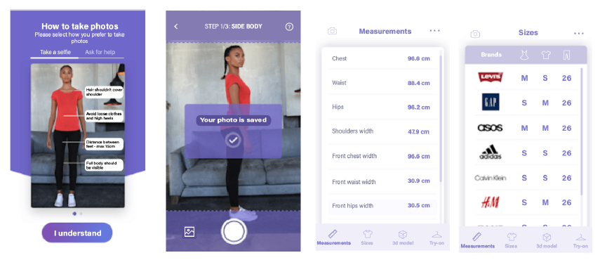

Figure 05: The screen of extracting and size recommendation with 3DLook [15]

## Virtual Try On

Virtual Try-on for Clothes using Deep Neural Networks is an emerging research field leveraging computer vision and deep learning techniques. It enables the creation of realistic clothing simulations on human bodies, allowing customers to virtually try on clothes before purchasing. This technology has the potential to transform the fashion industry by saving time, reducing waste, and increasing customer satisfaction. The paper [16] reviews existing virtual try-on techniques, outlines challenges, and proposes a new approach based on deep neural networks. This novel approach accurately simulates clothing fit and appearance on different body types, outperforming existing methods in realism and accuracy. It introduces a novel deep learning approach to enhance the accuracy and realism of virtual try-on simulations, offering promising applications in online fashion retail. It has practical applications in virtual wardrobe management, online shopping, and personalized styling, with the potential to revolutionize the online fashion shopping experience.

The Virtual Fitting Room (VFR) is a modern take on traditional fitting rooms, not limited to physical stores but also making its mark in the online shopping sector. With the rise of VFR technology, especially after Microsoft introduced the Kinect tracking system, it has become a intense topic of research and development. Arik Kurniawati et. [17] introduced an interactive 3D virtual fitting room, leveraging Microsoft's Kinect tracking system and harnessing the rigging technique found in 3D Modeling Blender to bring the VFR concept to life. This system manages the entire virtual fitting process, creating three-dimensional simulations and visual representations of clothing on virtual avatars that mimic real shoppers. Users have the freedom to observe these virtual garments in motion, adjusting to their body movements.

Rong Li et al. discussed an interactive 3D virtual fitting room system over the web [18]. It incorporates several key techniques, including 3D modeling, collision dictation, and real-time rendering. They also proposed a virtual Try-On system framework. In this system, users can use the system database to find appropriate virtual clothes, visit a fitting room, and continue matching. Users may rotate the manikin in different directions after determining that the clothing combination is satisfactory. This allows viewers to view the effects of the clothing from various angles. The system may also respond to user matching, provide helpful feedback, and improve the user's outfit match experience. This is more related to the proposed system.

Bernhard et. designed a system [19] for virtual clothing try-ons for Body metrics Ltd., at their request, for both retail and design. Customers can browse and try on clothes using their 3D scans, and the technology provides enough visual input to let them decide whether to buy or not. During the process, significant body landmarks and a huge number of size measurements are fully automatically derived from the customer's body scan. The system is also freely accessible on the Internet over a secure link. There are now several thousand customer scans in the central database. A market research study will be carried out to identify the main customer demands to improve the system.

T. Zhang et. [20] presents a virtual try-on system for online shopping that utilizes augmented reality and depth sensing technologies. The system allows users to virtually try on clothing items and provides accurate size recommendations based on body measurements. The authors conducted experiments to evaluate the system's performance and user satisfaction. The results showed that the system significantly improved the virtual try-on experience and increased user confidence in purchasing clothing online. The virtual try-on system based on augmented reality and depth sensing technology enhances the online shopping experience by providing accurate size recommendations and improving user satisfaction and confidence in purchasing clothing online.

# methodology

## In the process of conducting this review, a systematic and structured approach was employed to investigate the domains of Automated Size Recommendation and Immersive 3D Visualization. A comprehensive exploration was undertaken, involving thorough searches across prominent academic databases including IEEE Xplore, ResearchGate, and Google Scholar. The search queries encompassed a range of relevant keywords and phrases, such as "size recommendation," "virtual try-on," "3D model," "apparel industry," and "online shopping," among others. This meticulous and methodical search strategy ensured a comprehensive and in-depth examination of the existing body of knowledge in these research areas. Following a thorough search of the designated academic databases, 40 research papers were initially retrieved. A thorough filtering method was used to improve and focus the selection. As a result, 28 publications were chosen as extremely relevant and closely related to the proposed system’s objectives. This thorough collection of research material ensures that the resulting analysis is based on a small body of literature that is directly relevant to the topic matter.

## Moreover, considerations were extended to address research gaps and potential limitations which were encountered during the review process, promoting transparency in acknowledging potential biases or constraints. The synthesized findings informed a conclusive deduction, encapsulating the essence of the review’s discoveries. Also examined the forward-looking recommendations for future works of them.

## Throughout this process, crucial attention was paid to proper citation practices and adherence to ethical research principles. Importantly, the methodology underwent careful inspection by supervisors ensuring its cohesiveness, academic consistency, and alignment with the review’s key objectives.

# discussion

The above literature review provides a comprehensive overview of developments, trends, and challenges in the field of online applications in the virtual try-on concept. While the existing literature shows promise in various areas, several knowledge gaps and opportunities for further research have been identified. These gaps are discussed below, organized by the three sub-sections: Recommendation Systems, Immersive 3D Visualization, and Virtual Try-On.

Table 01 outlines the specific gaps in existing research and emphasizes the need for further exploration and development in the domain of virtual try-on technology, particularly in the areas of data collection optimization, ethical considerations, comprehensive size recommendation systems, and simplified 3D body shape estimation techniques. These gaps signify potential directions for future research and development to enhance the effectiveness and practicality of virtual try-on systems in the fashion industry.

Certainly, the knowledge gaps identified in Section II of the paper can be summarized in Table 01, as follows:

|  |  |
| --- | --- |
| Knowledge Gap | Discussion |
| Data Collection optimization for 3D size recommandation systems | The above review mentions various data collection approaches but doesn’t explore their advantages and limitations. So future research could optimize these techniques for efficency and accuracy. Previous studies get the data from the DeepFashion, This dataset includes a large collection of fashion images with annotations on clothing categories, attributes, and landmarks. It's widely used for various fashion-related tasks. But it also reduced the accuracy of the data. |
| Ethical Considerations in recommendation systems | The potential ethical implications and privacy concerns of using user data for recommendations are not discussed. This could investigate these ethical considerations. |
| Lack of size recommendation systems | There are numbers of recommendation systems for dress style and dress type. [7] But there is lack of researches for dress size recommendation systems. In present people are aware about their preferences and they need to purcharce the suitable dress size. So the Size recommendation systems are indeeded. |
| Simplified solutions for 3D body shape estimation | The research mentions a partial solution proposed by Anguelov et al., using the SCAPE model. This model can fit observed data when a high-resolution range image from a single perspective is provided. However, it has limitations in representing the entire body contour when certain areas are not visible in the observed data.  While complexity and restrictions in existing solutions are mentioned, future research could focus on simplifying these approaches to make them practical for industry adaptation. |

Table 01: The knowledge gap of the previous systems

Table 01 outlines the specific gaps in existing research and emphasizes the need for further exploration and development in the domain of virtual try-on technology, particularly in the areas of data collection optimization, ethical considerations, comprehensive size recommendation systems, and simplified 3D body shape estimation techniques. These gaps signify potential directions for future research and development to enhance the effectiveness and practicality of virtual try-on systems in the fashion industry.

# Conclusion

This research paper reviews automated size recommendation and immersive 3D visualization systems for revolutionizing the online shopping experience in the fashion industry. The study addresses the issue of clothing fit, which has been a persistent challenge in e-commerce, leading to high return rates and customer dissatisfaction. The review explores key developments in automated size recommendation systems, immersive 3D visualization, and virtual try-on technologies, including machine learning algorithms, body measurements, style preferences, and clothing attributes. It emphasizes the importance of realistic and interactive 3D visualizations for customers to assess fit and appearance. Several knowledge gaps and opportunities for future research were identified, including optimizing data collection techniques for 3D size recommendation systems, addressing ethical considerations in recommendation systems that use user data, and the need for more research in dress size recommendation systems. Additionally, there is room for further simplification of 3D body shape estimation techniques to make them more practical for industry adaptation.

Overall, this research paper contributes to the ongoing discussion on improving the online clothing purchasing experience, with the goal of making it easier, more enjoyable, and efficient for consumers worldwide. As the e-commerce landscape continues to evolve, the innovative solutions discussed in this paper hold the potential to reshape the fashion industry and enhance customer satisfaction in the online shopping scope.

##### References

[1] C. Bozzi, M. Neves, and C. Mont’Alvão, “Fashion E-Tail and the Impact of Returns: Mapping Processes and the Consumer Journey towards More Sustainable Practices,” *Sustainability*, vol. 14, no. 9, p. 5328, Apr. 2022, doi: 10.3390/su14095328.

[2] “China Internet Network Information Center,” *China Internet Netw. Inf. Cent.*, [Online]. Available: http://www.cnnic.net.cn

[3] “3DLook.” [Online]. Available: https://3dlook.ai/content-hub/apparel-return-rates-the-stats-retailers-cannot-ignore/.

[4] Li, Runze, Zhou, Yangping, Zhu, Shuaiyin, Mok, P.Y, “Intelligent Clothing Size and Fit Recommendations based on Human Model Customisation Technology,” [Online]. Available: https://dspace5.zcu.cz/bitstream/11025/29731/1/Li.pdf

[5] X. Hu, C. Zheng, J. Huang, R. Luo, J. Liu, and T. Peng, “Cloth texture preserving image-based 3D virtual try-on,” *Vis. Comput.*, vol. 39, no. 8, pp. 3347–3357, Aug. 2023, doi: 10.1007/s00371-023-02999-4.

[6] T. Islam, A. Miron, X. Liu, and Y. Li, “Image-Based Virtual Try-On: Fidelity and Simplification,” In Review, preprint, Jun. 2023. doi: 10.21203/rs.3.rs-3015514/v1.

[7] S. C. Hidayati, C.-C. Hsu, Y.-T. Chang, K.-L. Hua, J. Fu, and W.-H. Cheng, “What Dress Fits Me Best?: Fashion Recommendation on the Clothing Style for Personal Body Shape,” in *Proceedings of the 26th ACM international conference on Multimedia*, Seoul Republic of Korea: ACM, Oct. 2018, pp. 438–446. doi: 10.1145/3240508.3240546.

[8] Y.-R. Lin *et al.*, “Clothing Recommendation System based on Visual Information Analytics,” in *2019 International Automatic Control Conference (CACS)*, Keelung, Taiwan: IEEE, Nov. 2019, pp. 1–6. doi: 10.1109/CACS47674.2019.9024361.

[9] Y. Cho, L. S. S. Ray, K. S. P. Thota, S. Suh, and P. Lukowicz, “ClothFit: Cloth-Human-Attribute Guided Virtual Try-On Network Using 3D Simulated Dataset.” arXiv, Jun. 24, 2023. Accessed: Sep. 29, 2023. [Online]. Available: http://arxiv.org/abs/2306.13908

[10] Y. Yuan, M.-J. Park, and J.-H. Huh, “A Proposal for Clothing Size Recommendation System Using Chinese Online Shopping Malls: The New Era of Data,” *Appl. Sci.*, vol. 11, no. 23, p. 11215, Nov. 2021, doi: 10.3390/app112311215.

[11] “Taobao.” [Online]. Available: https://www.Taobao.com

[12] J. Shotton *et al.*, “Real-time human pose recognition in parts from single depth images,” in *CVPR 2011*, Colorado Springs, CO, USA: IEEE, Jun. 2011, pp. 1297–1304. doi: 10.1109/CVPR.2011.5995316.

[13] D. Anguelov, P. Srinivasan, D. Koller, S. Thrun, J. Rodgers, and J. Davis, “SCAPE: shape completion and animation of people,” in *ACM SIGGRAPH 2005 Papers*, Los Angeles California: ACM, Jul. 2005, pp. 408–416. doi: 10.1145/1186822.1073207.

[14] K. S. Prabhu Thota, S. Suh, B. Zhou, and P. Lukowicz, “Estimation Of 3d Body Shape And Clothing Measurements From Frontal-And Side-View Images,” in *2022 IEEE International Conference on Image Processing (ICIP)*, Bordeaux, France: IEEE, Oct. 2022, pp. 2631–2635. doi: 10.1109/ICIP46576.2022.9897520.

[15] “SAIA MTM API Documentation.” [Online]. Available: https://saia.3dlook.me/docs/#introduction

[16] Tarannum Shaikh, Vaishnavi Gosavi, Sejal Pawar, Sayali Shedge, and Shalaka Kharade, “Virtual Try-on for Clothes using Deep Neural Networks,” *Int. J. Adv. Res. Sci. Commun. Technol.*, pp. 778–784, Mar. 2023, doi: 10.48175/IJARSCT-8918.

[17] A. Kurniawati, A. Kusumaningsih, and Y. Aliffio, “Clothing size recommender on real-time fitting simulation using skeleton tracking and rigging,” *J. Teknol. Dan Sist. Komput.*, vol. 8, no. 2, pp. 127–132, Apr. 2020, doi: 10.14710/jtsiskom.8.2.2020.127-132.

[18] R. Li, K. Zou, X. Xu, Y. Li, and Z. Li, “Research of Interactive 3D Virtual Fitting Room on Web Environment,” in *2011 Fourth International Symposium on Computational Intelligence and Design*, Hangzhou, China: IEEE, Oct. 2011, pp. 32–35. doi: 10.1109/ISCID.2011.17.

[19] B. Spanlang, T. Vassilev, J. Walters, and B. F. Buxton, “A Virtual Clothing System for Retail and Design,” *Res. J. Text. Appar.*, vol. 9, no. 1, pp. 74–87, Feb. 2005, doi: 10.1108/RJTA-09-01-2005-B008.

[20] T. Zhang, W. Y. C. Wang, L. Cao, and Y. Wang, “The role of virtual try-on technology in online purchase decision from consumers’ aspect,” *Internet Res.*, vol. 29, no. 3, pp. 529–551, Jun. 2019, doi: 10.1108/IntR-12-2017-0540.

